C:\Users\John\AppData\Local\Microsoft\Windows\Temporary Internet Files\Content.IE5\6UCVXT07\MC900015063[1].wmf

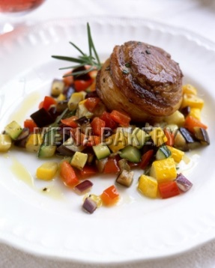 Recipe Credit: [mersaydees](http://share.food.com/community/mersaydees/style.esi?member_id=599450)

# Noisettes D’Agneau (Tender lamb chop, boned and rolled)

**Ingredients:**

Servings: 6

Update

Units: US | [Metric](http://www.food.com/recipe/noisettes-d-agneau-490808?mode=metric&scaleto=6.0&st=null)

3 tablespoons oil

2 lbs [lamb bones](http://www.food.com/library/lamb-203)

1 quart lamb broth, preferably homemade

2 [fresh tomatoes](http://www.food.com/library/tomato-151), cored

1/3 cup [onion](http://www.food.com/library/onion-148), coarsely chopped

1/3 cup [carrot](http://www.food.com/library/carrot-213), coarsely chopped

1/3 cup [celery](http://www.food.com/library/celery-216), coarsely chopped

1 tablespoon [tomato paste](http://www.food.com/library/tomato-paste-393)

1/2 cup [butter](http://www.food.com/library/butter-141), divided (1 stick)

48 ounces boneless lamb medallions (from small loin chops)

1/2 cup [dry white wine](http://www.food.com/library/wine-184)

1 tablespoon [shallot](http://www.food.com/library/shallot-127), minced

1/2 cup fresh tarragon leaves

3 tablespoons goose liver pate, cut into small cubes

12 [artichoke hearts](http://www.food.com/library/artichoke-188), cooked

12 tablespoons [tomatoes](http://www.food.com/library/tomato-151), peeled, seeded and chopped (3/4 cup)

**Directions:**

Heat oil in Dutch oven over medium-high heat. Toss in lamb bones and brown on all sides, about 5 minutes per side. Stir in broth, cored tomatoes, onion, carrot, celery and tomato paste and boil until sauce is reduced to 3 cups, about 20 minutes. Strain liquid and reserve.

In large skillet over medium-high heat, melt ¼ cup butter. Add lamb medallions, in batches if necessary, and sauté until medium-rare, about 7 to 8 minutes per side. Transfer lamb to platter and keep warm.

Add wine and shallot to skillet and bring to boil, scraping up any browned bits. Stir in reduced lamb liquid and tarragon and boil 15 minutes. Swirl in remaining ¼ cup butter and pate; remove sauce from heat.

If necessary, plunge artichoke hearts into boiling water to reheat; drain and pat dry. Arrange on heated platter. Spoon 1 tablespoon chopped tomato over each artichoke heart. Top each with 1 lamb medallion. Spoon some of the sauce over. Serve immediately, offering remaining sauce separately.